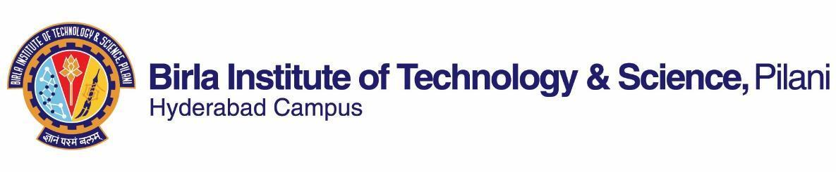

**SECOND SEMESTER 2022-2023**

# Course Handout Part II

16-1-2023

In addition to Part-I (General Handout for all courses appended to the time table), this portion gives further specific details regarding the course.

*Course No* **:** BITS F399

*Course Title* : Humanistic Theories of Science and Technology

*Instructor-in-Charge* : Biswanath Dash

**Scope and objective of the course:**

This course will introduce ways of considering the interrelationship among three major dimensions of our culture-- science, technology and humanistic orientation. It draws from ‘Science Technology Studies (STS)’; an emerging area of inquiry that has become popular in recent times in major universities around the world. It focuses on learning alternate ways of thinking about science and technology, in which students are encouraged to question the ‘taken for granted’ ideas about scientific knowledge and evolution of technological artifacts. The purpose and intent is to constructively probe all forms of knowing including science and critically engage with it. The course offers scope to glean through mutual shaping of society and ‘science/technology’ and uses several case studies to learn and reflect on how progress is conceptualized.

**Text Book:**

1. Sismondo, Sergio. 2004. *An introduction to Science and Technology Studies*. UK: Blackwell Publishing.
2. Reference papers to be uploaded on CMS

**Course Plan:**

|  |  |  |  |
| --- | --- | --- | --- |
| **Lecture No.** | **Learning Objective** | **Topics to be covered** | **Chapter in the Text Book** |
| 1-2 | Understanding the core concepts | Science, Technology, Humanities : their Interrelationship | TB Chapter 1 |
| 3-10 | To get an introduction to conceptual and theoretical debates concerning science and its method: Philosophy and History | Debates of Rationality- Plato, Descartes, Chomsky.  Debates over Empiricism- Francis Bacon, John Locke.  Evolution of Scientific Method- Galileo, Newton. | Reading materials |
| 11-20 | An introduction to ‘Science and Technology Studies’ (STS) | Understanding growth of science- Popper and Kuhn  Criticisms-Paul Feyerabend  Synthesis: Lakatos | TB Chapter 2,  Reading material |
| 21-25 | Gain a perspective on ‘Sociology of Science’ | Institutional view of science,  Sociology of Knowledge and  Introduction to Social Construction | TB-Chapter 3-6 |
| 26-32 | To critically analyze ‘social constructivist’ framework | Mutual shaping of science, technology and society.  Social Construction of Technology;  Innovation Studies  Actor Network Theory;  Laboratory studies | Reading materials,  TB Chapter 7,8, 9, 10,11,12 |
| 33-39 | To reflect on critical and cultural studies of science and technology | Gender and science;  Public Understanding of Science;  Science Communication | TB Chapter 15 and 16, Reading materials |

**Evaluation Scheme:**

|  |  |  |  |  |
| --- | --- | --- | --- | --- |
| **Component** | **Duration** | **Weightage (%)** | **Date & Time** | **Nature of Component** |
| Mid Semester Test | 90 minutes | 30 | 16/03 9.30 - 11.00AM | Closed Book |
| Assignment |  | 20 | TBA | Open Book |
| Quiz |  | 15 | TBA | Closed Book |
| Comprehensive Examination | 3hrs. | 35 | 15/05 FN | Closed Book |

**Chamber consultation Hours:** Thursday 11-12. Room No. K 131

**Notices:** Notices, if any, will be displayed on Department Notice Board and CMS.

**Make-up:** The make-up for an evaluation component such as Mid Sem./CE will be given only in genuine cases.

**Academic Honesty and Integrity Policy**: Academic honesty and integrity are to be maintained by all the students throughout the semester and no type of academic dishonesty is acceptable.



**Biswanath Dash**

**INSTRUCTOR-IN-CHARGE**